**A Dual-Layer Security Approach for Cloud Data Using Cryptography and Steganography**

**ABSTARCT :**

In the contemporary digital era, the confidentiality and integrity of sensitive data have become critical concerns due to the proliferation of cyber threats and the vast amount of information exchange over public networks. This project presents a dual-layer security framework combining cryptography and steganography to protect data uploads and access in a three­module system comprising users, owners, and a cloud platform. The first layer encrypts the file content using a symmetric encryption algorithm, and the second layer conceals the encrypted data within a cover image using least significant bit (LSB) steganography before storage. Through this two-step mechanism, the existence of the secret data is hidden and its content is unintelligible without the key. The cloud module oversees registration, file tracking, and request monitoring, while owners control access and Owners perform uploads, users send requests and download approved files. The proposed system demonstrates improved data security, access control, and user-friendly functionality in a real-world application context.

**KEYWORDS**

cryptography · steganography · dual-layer security · least significant bit · data concealment

**AIM**

To design and implement a secure system that protects user-uploaded data via a dual-layer mechanism of encryption and steganographic embedding, while enabling controlled access and monitoring through user, owner and cloud modules.

**OBJECTIVE**

· To implement symmetric encryption of user data so that its content cannot be read without the key.

· To embed encrypted data inside a cover image using steganography, hiding both content and existence of the data.

· To build a user interface where users can upload files, owners can approve access and the cloud module monitors registrations, files and requests.

· To ensure that only authorized users can download and decrypt the embedded data, and track all interactions in a database.

·

**PROBLEM STATEMENT**

In many current systems, either data is encrypted or hidden, but seldom both, and often there is inadequate control over who can access the decrypted content. Additionally, monitoring of user, owner and file/request activity is weak. This project addresses the challenge of providing enhanced data security through a combined cryptographic-steganographic approach, coupled with controlled access and centralized oversight.

**INTRODUCTION**

In today’s interconnected world, massive volumes of data are transmitted, stored and shared across various platforms. With this growth comes an increasing risk of data breaches, unauthorized access and information leakage. Traditional approaches such as simple encryption, though effective in concealing content, may still reveal the fact that a secret exchange is taking place. Meanwhile, steganography — the art of hiding information within innocuous files — conceals the existence of the message, but alone cannot ensure the message content remains secure if extracted.  
By integrating these two techniques into a dual-layer security framework, we can protect both the content and the existence of sensitive data. In this project, a user uploads a text file, which is first encrypted using a strong algorithm. The encrypted bytes are then embedded into the least significant bits of a cover image file, producing a “stego” image that appears normal. This image is stored in the system. Access to the original data is subject to approval by an owner module, while a cloud module tracks registrations, files and access requests.  
Users register and log in, upload files, send requests for file access. Owners log in, review requests and approve or reject them. The cloud administrator module allows viewing of all users (both users and owners), all uploaded files, and all requests. The functionality flows end-to-end: upload → encryption → embedding → storage → request → approval → extraction → decryption → download.  
The key benefit of this model is multiplicative: even if the stego-image is intercepted, the actual content remains encrypted and hidden; even if the encryption is broken, the fact of hidden data remains unknown. This layered defense makes unauthorized access extremely difficult. Additionally, centralized tracking ensures accountability and control.  
Through implementation of this system using a web-based interface (Flask + MySQL + PIL/Python), we demonstrate a practical solution for enhanced data security in a multi-user environment.  
Adoption of such dual-layer strategies will become increasingly important as cyber attacks evolve and data privacy regulations grow stricter. The integration of multiple security layers, access control, and monitoring provides a robust architecture for modern data protection.

窗体顶端

窗体底端

**SYSTEM ANALYSIS**

**EXISTING SYSTEM**

In many existing systems, data is either encrypted or hidden, but rarely both in a structured access-controlled framework. Users may upload files and encryption may be applied, but steganographic hiding is not used; or steganography is used without robust access control and monitoring. These systems often lack unified modules to track users, upload activity and requests across a cloud environment.

**DISADVANTAGES**:

· Encryption alone reveals that secret data exists, which may attract attention.

· Steganography alone does not protect the content if extraction occurs.

· Lack of centralized tracking means file uploads and requests may go unchecked.

**PROPOSED SYSTEM**

The proposed system implements a dual-layer security model: first encrypting user data using AES (or similar symmetric algorithm) then embedding the encrypted bytes into an image using LSB steganography. A three-module architecture (user, owner, cloud) manages upload, approval, download and monitoring. This model hides the existence of secret data and protects its content, while enabling controlled access and centralized oversight.

**ADVANTAGES**

· Stronger security: two layers (encryption + hiding) instead of one.

· Concealment: the hidden data cannot easily be detected in the cover image.

· Controlled access: owners approve downloads, cloud tracks activities.

· Auditability: cloud module records users, owners, files and requests.

· **SYSTEM REQUIREMENTS:**

**HARDWARE REQUIREMENTS:**

* Processor : intel Core.
* SSD : 512 GB.
* Monitor : 15’’ LED
* Input Devices : Keyboard, Mouse
* Ram : 1 GB

**SOFTWARE REQUIREMENTS:**

* Operating system : Windows 10.
* Coding Language : python
* Database : MySQL
* framework : flask
* Technologies : pdbc

**SYSTEM ARCHITECTURE**

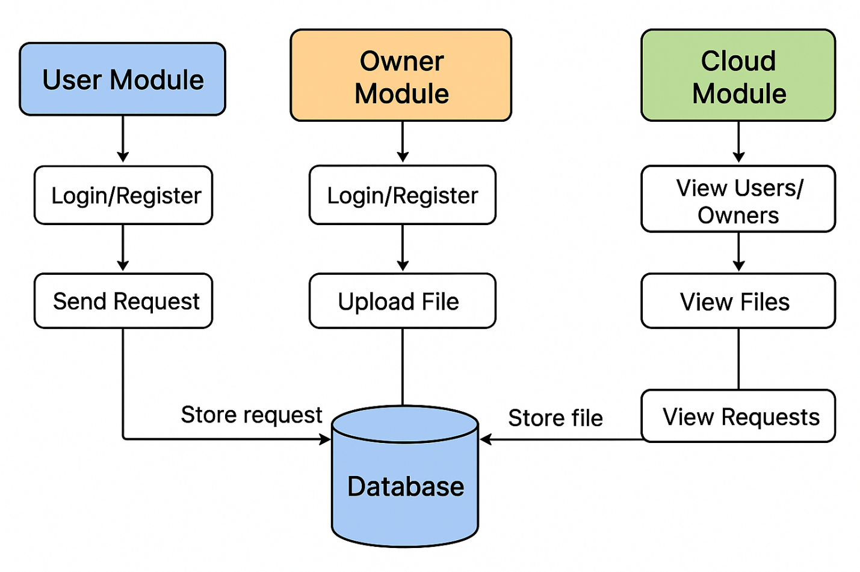

**IMPLEMENTATION**

**IMPLEMENTATION**

1. **USER**
2. **ADMIN**
3. **CLOUD**

**MODULE DESCRIPTION**

**USER**

Allows registration, login , request for access, view/download of approved files, logout.

**OWNER**

Allows owner registration/login, view of uploaded files by that owner, view of requests, acceptance or rejection of requests, logout.

**CLOUD**

Allows cloud administrator login, viewing of all users and owners registered, viewing of all uploaded files (with owner, data length, status), viewing of all requests system-wide (with status, user email, owner, date).

**SYSTEM DESIGN**

**UML DIAGRAMS**

UML stands for Unified Modeling Language. UML is a standardized general-purpose modeling language in the field of object-oriented software engineering. The standard is managed, and was created by, the Object Management Group.

The goal is for UML to become a common language for creating models of object oriented computer software. In its current form UML is comprised of two major components: a Meta-model and a notation. In the future, some form of method or process may also be added to; or associated with, UML.

The Unified Modeling Language is a standard language for specifying, Visualization, Constructing and documenting the artifacts of software system, as well as for business modeling and other non-software systems.

The UML represents a collection of best engineering practices that have proven successful in the modeling of large and complex systems.The UML is a very important part of developing objects oriented software and the software development process. The UML uses mostly graphical notations to express the design of software projects.

**GOALS:**

The Primary goals in the design of the UML are as follows:

1. Provide users a ready-to-use, expressive visual modeling Language so that they can develop and exchange meaningful models.
2. Provide extendibility and specialization mechanisms to extend the core concepts.
3. Be independent of particular programming languages and development process.
4. Provide a formal basis for understanding the modeling language.
5. Encourage the growth of OO tools market.
6. Support higher level development concepts such as collaborations, frameworks, patterns and components.
7. Integrate best practices.

**USE CASE DIAGRAM:**

A use case diagram in the Unified Modeling Language (UML) is a type of behavioral diagram defined by and created from a Use-case analysis. Its purpose is to present a graphical overview of the functionality provided by a system in terms of actors, their goals (represented as use cases), and any dependencies between those use cases. The main purpose of a use case diagram is to show what system functions are performed for which actor. Roles of the actors in the system can be depicted.

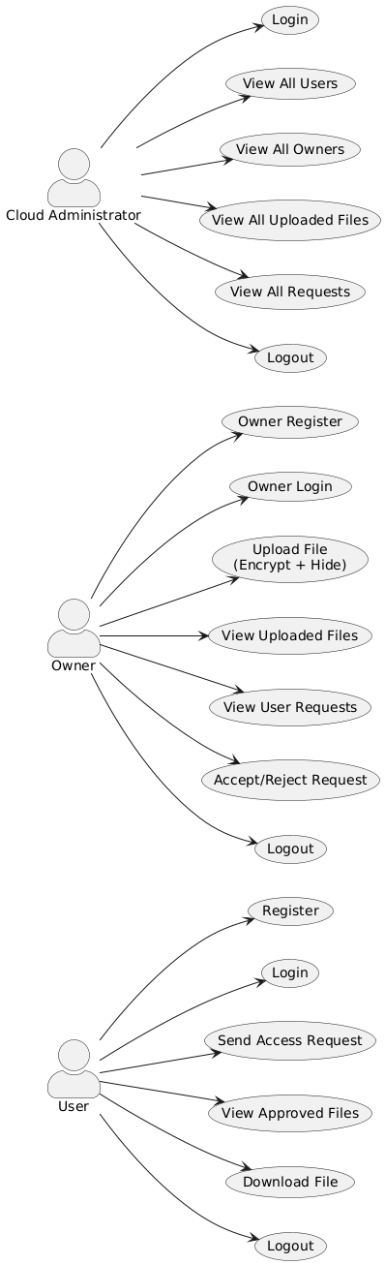

**CLASS DIAGRAM:**

In software engineering, a class diagram in the Unified Modeling Language (UML) is a type of static structure diagram that describes the structure of a system by showing the system's classes, their attributes, operations (or methods), and the relationships among the classes. It explains which class contains information.

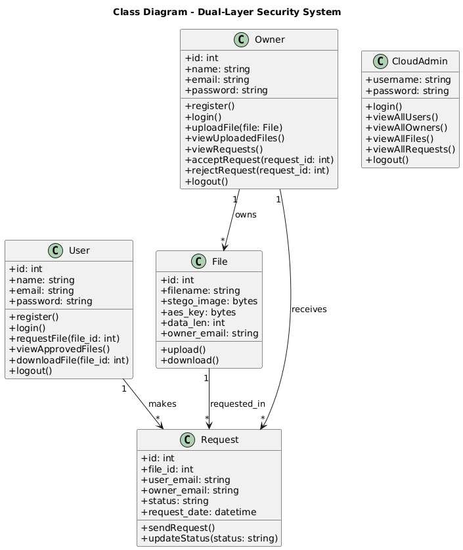

**SEQUENCE DIAGRAM:**

A sequence diagram in Unified Modeling Language (UML) is a kind of interaction diagram that shows how processes operate with one another and in what order. It is a construct of a Message Sequence Chart. Sequence diagrams are sometimes called event diagrams, event scenarios, and timing diagrams.

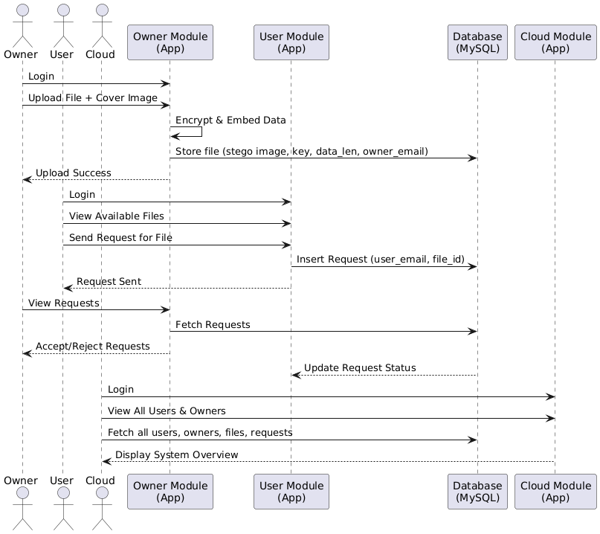

**ACTIVITY:**An Activity Diagram is a type of UML diagram that represents the dynamic aspects of a system. It is primarily used to model the flow of control or activities in a process, system, or use case. This diagram is particularly useful in modeling the workflow of a system and how different actions or steps are performed, helping to visualize both sequential and parallel flows.

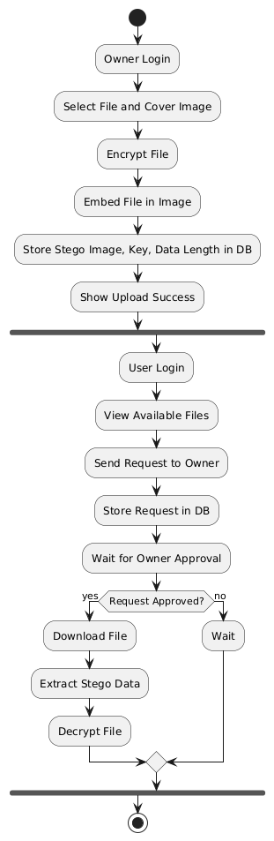

**DEPLOYMNET :**

A deployment diagram is a type of UML diagram that shows the physical deployment of software components on hardware nodes. It is used to visualize the hardware, software, and their relationships in a system, essentially showing where and how system components run. The main elements of a deployment diagram are nodes, which represent hardware devices or execution environments like servers or client computers; artifacts, which are software components or files deployed on the nodes such as applications, libraries, or databases; and communication paths, which show connections between nodes representing network links

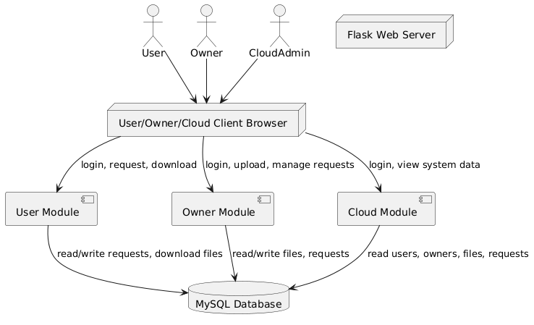

**DATA FLOW :**

A data flow diagram (DFD) is a graphical representation that shows how data moves through a system. It illustrates the flow of information between processes, data stores, and external entities. The main components of a DFD are **processes**, which transform input data into output; **data stores**, which represent where data is stored; **data flows**, which show the movement of data between components; and **external entities**, which are sources or destinations of data outside the system. DFDs are useful for understanding system functionality, identifying inefficiencies, and designing or analyzing systems. They can be drawn at different levels, from a **high-level overview (Level 0)** showing major processes to more detailed **Level 1 or Level 2 diagrams** that break down processes into sub-processes.

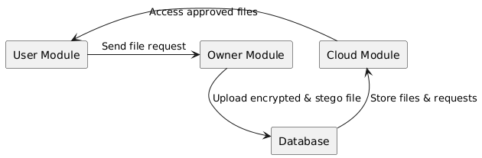

**LEVEL 0**

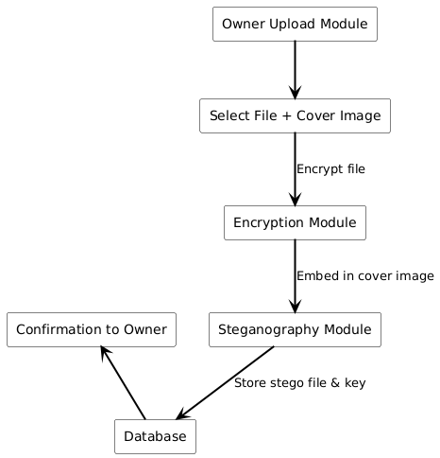

LEVEL 1

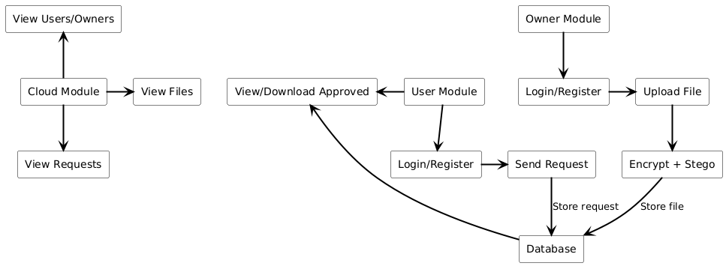

LEVEL 2

**LITERATURAL SURVEY**

**TITLE: “Double layer security using crypto-stego techniques”**  
AUTHORS: A. Jan  
ABSTRACT: The research paper investigates the integration of cryptographic and steganographic techniques to create a double-layer security approach for data transmission. The study argues that while cryptography secures the content of a message, steganography conceals its existence. By using a covert channel (image) to embed encrypted data, the proposed method reduces detection risk. The authors provide a detailed implementation using AES encryption followed by LSB embedding, and evaluate performance in terms of visual fidelity of stego images. Their experimental results show that combining the methods results in stronger security than either method alone.

**TITLE: “Multi-Layered Security Framework Combining Steganography and DNA Coding”**  
AUTHORS: B. Kallapu, A. N. Janardhan, R. M. Hejamadi et al.  
ABSTRACT: This paper proposes a multi-layered framework that integrates AES encryption, DNA sequence encoding for key generation, QR codes, and LSB steganography for embedding encrypted data in images. The framework aims to enhance data protection by increasing key-space complexity, embedding unpredictability and hiding the existence of hidden data. The authors evaluate their technique via security metrics like NPCR, UACI, PSNR and entropy. The results demonstrate robustness and imperceptibility of the system, suggesting its suitability for high-security applications in domains such as finance and healthcare.

**TITLE: “LSB Steganography using Dual Layer for Text Crypto-Stego”**  
AUTHORS: M. M. Abd Zaid, A. Ali Talib Al-khazaali, A. Abed Mohammed  
ABSTRACT: This work presents an integrated method for securely transmitting data by first encrypting a text file using a symmetric algorithm and then embedding the ciphertext into an image using LSB steganography. The paper emphasises performance metrics for distortion (PSNR, MSE) and payload capacity, and shows that the dual-layer approach increases payload capacity while maintaining acceptable image quality.

**TITLE: “Double layer steganography technique using DNA sequences and images as carriers for sensitive data”**  
AUTHORS: A. O. Aljahdali  
ABSTRACT: The study explores a multi-layer steganography technique that uses DNA sequence encoding as one layer and image steganography as another. The secret data is first converted to a DNA-coded format, then embedded in an image. The authors discuss security advantages of biological encoding combined with image hiding, especially for sensitive data such as medical records.

**TITLE: “Multi-Layered Security System: Integrating Quantum Key Distribution with Classical Cryptography to Enhance Steganographic Security”**  
AUTHORS: A. Sykot, M. S. Azad, W. R. Tanha et al.  
ABSTRACT: This paper presents a novel framework combining quantum key distribution (QKD) for key exchange with classical symmetric encryption and steganographic embedding. The approach ensures that the encryption key is generated via quantum processes, enhancing resistance against both classical and quantum attacks, and hides the encrypted data within images.

**TITLE: “Dual Layer Security of data using LSB Image Steganography Method and AES Encryption Algorithm”**  
AUTHORS: S. Singh & V. K. Attri  
ABSTRACT: In this earlier foundational work, the authors proposed a system where a secret message is first hidden via LSB in an image and then the resulting stego image is encrypted using AES-128. The dual layering ensures that even detection of hidden data does not reveal its content. They discuss embedding capacity, image quality, and encryption overhead.

**TITLE: “A deep learning-driven multi-layered steganographic approach for enhanced data security”**  
AUTHORS: Y. Sanjalawe, S. Al-E’mari, S. Fraihat, M. Abualhaj & E. Alzubi  
ABSTRACT: This contemporary work integrates Huffman coding, LSB embedding and a deep learning encoder-decoder to embed secret data in images. The multi-layered structure improves payload, imperceptibility (SSIM>99%), and robustness against steganalysis and compression attacks.

**TITLE: “Enhanced Tiny Encryption Algorithm with Embedding (ETEA)”**  
AUTHORS: D. Virmani, N. Beniwal, G. Mandal & S. Talwar  
ABSTRACT: Although not directly combining steganography, this paper illustrates how embedding data with encryption improves security of data transmission. The study discusses algorithmic improvements and embedding strategies.

**TITLE: “A novel magic LSB substitution method (M-LSB-SM) using multi-level encryption and achromatic component of an image”**  
AUTHORS: K. Muhammad, M. Sajjad, I. Mehmood, S. Rho & S. W. Baik  
ABSTRACT: The article proposes a refined LSB embedding method in the HSI color space combined with multi-level encryption. While steganography is focused, the concept of layering encryption inside embedding forms a useful parallel to your project’s dual-layer concept.

**TITLE: “Steganalysis”**  
AUTHORS: Wikipedia contributors  
ABSTRACT: This article discusses methods of detecting hidden data (steganography) and outlines how independent detection and analysis of hidden content work. While not a primary research paper, it provides context for why hiding existence of data matters.

**SOFTWARE ENVIRONMENT**

**1.1 PYTHON**

Python is a **high-level, interpreted**, **interactive** and **object-oriented scriptinglanguage**. Python is designed to be highly readable. It uses English keywords frequently where as other languages use punctuation, and it has fewer syntactical constructions than other languages.

* **Python is Interpreted:** Python is processed at runtime by the interpreter. You do not need to compile your program before executing it. This is similar to PERL and PHP.
* **Python is Interactive:** You can actually sit at a Python prompt and interact with the interpreter directly to write your programs.
* **Python is Object-Oriented:** Python supports Object-Oriented style or technique of programming that encapsulates code within objects.
* **Python is a Beginner's Language:** Python is a great language for the beginner-level programmers and supports the development of a wide range of applications from simple text processing to WWW browsers to games.

## 1.2 History of Python

Python was developed by Guido van Rossum in the late eighties and early nineties at the National Research Institute for Mathematics and Computer Science in the Netherlands.

Python is derived from many other languages, including ABC, Modula-3, C, C++, Algol-68, SmallTalk, and Unix shell and other scripting languages.

Python is copyrighted. Like Perl, Python source code is now available under the GNU General Public License (GPL).

Python is now maintained by a core development team at the institute, although Guido van Rossum still holds a vital role in directing its progress.

## 1.3 Python Features

Python's features include:

* **Easy-to-learn:** Python has few keywords, simple structure, and a clearly defined syntax. This allows the student to pick up the language quickly.
* **Easy-to-read:** Python code is more clearly defined and visible to the eyes.
* **Easy-to-maintain:** Python's source code is fairly easy-to-maintain.
* **A broad standard library:** Python's bulk of the library is very portable and cross-platform compatible on UNIX, Windows, and Macintosh.
* **Interactive Mode:** Python has support for an interactive mode which allows interactive testing and debugging of snippets of code.
* **Portable:** Python can run on a wide variety of hardware platforms and has the same interface on all platforms.
* **Extendable:** You can add low-level modules to the Python interpreter. These modules enable programmers to add to or customize their tools to be more efficient.
* **Databases:** Python provides interfaces to all major commercial databases.
* **GUI Programming:** Python supports GUI applications that can be created and ported to many system calls, libraries and windows systems, such as Windows MFC, Macintosh, and the X Window system of Unix.
* **Scalable:** Python provides a better structure and support for large programs than shell scripting.

Python has a big list of good features:

* It supports functional and structured programming methods as well as OOP.
* It can be used as a scripting language or can be compiled to byte-code for building large applications.
* It provides very high-level dynamic data types and supports dynamic type checking.
* IT supports automatic garbage collection.
* It can be easily integrated with C, C++, COM, ActiveX, CORBA, and Java.

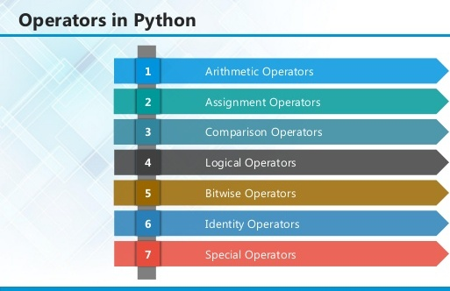

**2.1 ARITHMETIC OPERATORS**

|  |  |  |
| --- | --- | --- |
| **Operator** | **Description** | **Example** |
| + Addition | Adds values on either side of the operator. | a + b = 30 |
| - Subtraction | Subtracts right hand operand from left hand operand. | a – b = -10 |
| * Multiplication | Multiplies values on either side of the operator | a * b = 200 |
| / Division | Divides left hand operand by right hand operand | b / a = 2 |
| % Modulus | Divides left hand operand by right hand operand and returns remainder | b % a = 0 |
| ** Exponent | Performs exponential (power) calculation on operators | a**b =10 to the power 20 |
| // | Floor Division - The division of operands where the result is the quotient in which the digits after the decimal point are removed. But if one of the operands is negative, the result is floored, i.e., rounded away from zero (towards negative infinity): | 9//2 = 4 and 9.0//2.0 = 4.0, -11//3 = -4, -11.0//3 = -4.0 |

**2.2ASSIGNMENT OPERATOR**

|  |  |  |
| --- | --- | --- |
| **Operator** | **Description** | **Example** |
| = | Assigns values from right side operands to left side operand | c = a + b assigns value of a + b into c |
| += Add AND | It adds right operand to the left operand and assign the result to left operand | c += a is equivalent to c = c + a |
| -= Subtract AND | It subtracts right operand from the left operand and assign the result to left operand | c -= a is equivalent to c = c - a |
| *= Multiply AND | It multiplies right operand with the left operand and assign the result to left operand | c *= a is equivalent to c = c * a |
| /= Divide AND | It divides left operand with the right operand and assign the result to left operand | c /= a is equivalent to c = c / ac /= a is equivalent to c = c / a |

|  |  |  |
| --- | --- | --- |
| %= Modulus AND | It takes modulus using two operands and assign the result to left operand | c %= a is equivalent to c = c % a |
| **= Exponent AND | Performs exponential (power) calculation on operators and assign value to the left operand | c **= a is equivalent to c = c ** a |
| //= Floor Division | It performs floor division on operators and assign value to the left operand | c //= a is equivalent to c = c // a |

**2.3 IDENTITY OPERATOR**

|  |  |  |
| --- | --- | --- |
| **Operator** | **Description** | **Example** |
| is | Evaluates to true if the variables on either side of the operator point to the same object and false otherwise. | x is y, here **is** results in 1 if id(x) equals id(y). |
| is not | Evaluates to false if the variables on either side of the operator point to the same object and true otherwise. | x is not y, here **is not** results in 1 if id(x) is not equal to id(y |

**2.4 COMPARISON OPERATOR**

|  |  |  |
| --- | --- | --- |
| **Operator** | **Description** | **Example** |
| & Binary AND | Operator copies a bit to the result if it exists in both operands | (a & b) (means 0000 1100) |
| | Binary OR | It copies a bit if it exists in either operand. | (a | b) = 61 (means 0011 1101) |
| ^ Binary XOR | It copies the bit if it is set in one operand but not both. | (a ^ b) = 49 (means 0011 0001) |
| ~ Binary Ones Complement | It is unary and has the effect of 'flipping' bits. | (~a ) = -61 (means 1100 0011 in 2's complement form due to a signed binary number. |
| << Binary Left Shift | The left operands value is moved left by the number of bits specified by the right operand. | a << 2 = 240 (means 1111 0000) |
| >> Binary Right Shift | The left operands value is moved right by the number of bits specified by the right operand. | a >> 2 = 15 (means 0000 1111) |

**2.5 LOGICAL OPERATOR**

|  |  |  |
| --- | --- | --- |
| **Operator** | **Description** | **Example** |
| and Logical AND | If both the operands are true then condition becomes true. | (a and b) is true. |
| or Logical OR | If any of the two operands are non-zero then condition becomes true. | (a or b) is true. |
| not Logical NOT | Used to reverse the logical state of its operand. | Not(a and b) is false. |

## 2.6Membership Operators

|  |  |  |
| --- | --- | --- |
| **Operator** | **Description** | **Example** |
| in | Evaluates to true if it finds a variable in the specified sequence and false otherwise. | x in y, here in results in a 1 if x is a member of sequence y. |
| not in | Evaluates to true if it does not finds a variable in the specified sequence and false otherwise. | x not in y, here not in results in a 1 if x is not a member of sequence y. |

## Python Operators Precedence

|  |  |
| --- | --- |
| **Operator** | **Description** |
| ** | Exponentiation (raise to the power) |
| ~ + - | Complement, unary plus and minus (method names for the last two are +@ and -@) |
| * / % // | Multiply, divide, modulo and floor division |
| + - | Addition and subtraction |
| >><< | Right and left bitwise shift |
| & | Bitwise 'AND' |  |
| ^ | | Bitwise exclusive `OR' and regular `OR' |  |
| <= <>>= | Comparison operators |  |
| <> == != | Equality operators |  |
| = %= /= //= -= += *= **= | Assignment operators |  |
| is is not | Identity operators |  |
| in not in | Membership operators |  |
| not or and | Logical operators |  |

**3.1 LIST**

The list is a most versatile data type available in Python which can be written as a list of comma-separated values (items) between square brackets. Important thing about a list is that items in a list need not be of the same type.

Creating a list is as simple as putting different comma-separated values between square brackets. For example −

list1 =['physics','chemistry',1997,2000];

list2 =[1,2,3,4,5];

list3 =["a","b","c","d"]

## Basic List Operations

Lists respond to the + and * operators much like strings; they mean concatenation and repetition here too, except that the result is a new list, not a string.

|  |  |  |
| --- | --- | --- |
| **Python Expression** | **Results** | **Description** |
| len([1, 2, 3]) | 3 | Length |
| [1, 2, 3] + [4, 5, 6] | [1, 2, 3, 4, 5, 6] | Concatenation |
| ['Hi!'] * 4 | ['Hi!', 'Hi!', 'Hi!', 'Hi!'] | Repetition |
| 3 in [1, 2, 3] | True | Membership |
| for x in [1, 2, 3]: print x, | 1 2 3 | Iteration |

## Built-in List Functions & Methods:

Python includes the following list functions −

|  |  |
| --- | --- |
| **SN** | **Function with Description** |
| 1 | [cmp(list1, list2)](https://www.tutorialspoint.com/python/list_cmp.htm)  Compares elements of both lists. |
| 2 | [len(list)](https://www.tutorialspoint.com/python/list_len.htm)  Gives the total length of the list. |
| 3 | [max(list)](https://www.tutorialspoint.com/python/list_max.htm)  Returns item from the list with max value. |
| 4 | [min(list)](https://www.tutorialspoint.com/python/list_min.htm)  Returns item from the list with min value. |
| 5 | [list(seq)](https://www.tutorialspoint.com/python/list_list.htm)  Converts a tuple into list. |

Python includes following list methods

|  |  |
| --- | --- |
| **SN** | **Methods with Description** |
| 1 | [list.append(obj)](https://www.tutorialspoint.com/python/list_append.htm)  Appends object obj to list |
| 2 | [list.count(obj)](https://www.tutorialspoint.com/python/list_count.htm)  Returns count of how many times obj occurs in list |
| 3 | [list. extend(seq)](https://www.tutorialspoint.com/python/list_extend.htm)  Appends the contents of seq to list |
| 4 | [list.index(obj)](https://www.tutorialspoint.com/python/list_index.htm)  Returns the lowest index in list that obj appears |
| 5 | [list.insert(index, obj)](https://www.tutorialspoint.com/python/list_insert.htm)  Inserts object obj into list at offset index |
| 6 | [list.pop(obj=list[-1])](https://www.tutorialspoint.com/python/list_pop.htm)  Removes and returns last object or obj from list |
| 7 | [list.remove(obj)](https://www.tutorialspoint.com/python/list_remove.htm)  Removes object obj from list |
| 8 | [list.reverse()](https://www.tutorialspoint.com/python/list_reverse.htm)  Reverses objects of list in place |
| 9 | [list.sort([func])](https://www.tutorialspoint.com/python/list_sort.htm)  Sorts objects of list, use compare function if given |

**3.2 TUPLES**

A tuple is a sequence of immutable Python objects. Tuples are sequences, just like lists. The differences between tuples and lists are, the tuples cannot be changed unlike lists and tuples use parentheses, whereas lists use square brackets.

Creating a tuple is as simple as putting different comma-separated values. Optionally we can put these comma-separated values between parentheses also. For example −

tup1 =('physics','chemistry',1997,2000);

tup2 =(1,2,3,4,5);

tup3 ="a","b","c","d";

The empty tuple is written as two parentheses containing nothing −

tup1 =();

To write a tuple containing a single value you have to include a comma, even though there is only one value −

tup1 =(50,);

Like string indices, tuple indices start at 0, and they can be sliced, concatenated, and so on.

## Accessing Values in Tuples:

To access values in tuple, use the square brackets for slicing along with the index or indices to obtain value available at that index. For example –

tup1 =('physics','chemistry',1997,2000);

tup2 =(1,2,3,4,5,6,7);

print"tup1[0]: ", tup1[0]

print"tup2[1:5]: ", tup2[1:5]

When the code is executed, it produces the following result −

tup1[0]: physics

tup2[1:5]: [2, 3, 4, 5]

## Updating Tuples:

Tuples are immutable which means you cannot update or change the values of tuple elements. We are able to take portions of existing tuples to create new tuples as the following example demonstrates −

tup1 =(12,34.56);

tup2 =('abc','xyz');

tup3 = tup1 + tup2;

print tup3

When the above code is executed, it produces the following result −

(12, 34.56, 'abc', 'xyz')

## Delete Tuple Elements

Removing individual tuple elements is not possible. There is, of course, nothing wrong with putting together another tuple with the undesired elements discarded.

To explicitly remove an entire tuple, just use the **del** statement. For example:

tup =('physics','chemistry',1997,2000);

print tup

del tup;

print"After deleting tup : "

print tup

## Basic Tuples Operations:

|  |  |  |
| --- | --- | --- |
| **Python Expression** | **Results** | **Description** |
| len((1, 2, 3)) | 3 | Length |
| (1, 2, 3) + (4, 5, 6) | (1, 2, 3, 4, 5, 6) | Concatenation |
| ('Hi!',) * 4 | ('Hi!', 'Hi!', 'Hi!', 'Hi!') | Repetition |
| 3 in (1, 2, 3) | True | Membership |
| for x in (1, 2, 3): print x, | 1 2 3 | Iteration |

## Built-in Tuple Functions

|  |  |
| --- | --- |
| **SN** | **Function with Description** |
| 1 | **[cmp(tuple1, tuple2)](https://www.tutorialspoint.com/python/tuple_cmp.htm)**:Compares elements of both tuples. |
| 2 | **[len(tuple)](https://www.tutorialspoint.com/python/tuple_len.htm)**:Gives the total length of the tuple. |
| 3 | **[max(tuple)](https://www.tutorialspoint.com/python/tuple_max.htm)**:Returns item from the tuple with max value. |
| 4 | **[min(tuple)](https://www.tutorialspoint.com/python/tuple_min.htm)**:Returns item from the tuple with min value. |
| 5 | **[tuple(seq)](https://www.tutorialspoint.com/python/tuple_tuple.htm)**:Converts a list into tuple. |

**3.2 DICTIONARY**

Each key is separated from its value by a colon (:), the items are separated by commas, and the whole thing is enclosed in curly braces. An empty dictionary without any items is written with just two curly braces, like this: {}.

Keys are unique within a dictionary while values may not be. The values of a dictionary can be of any type, but the keys must be of an immutable data type such as strings, numbers, or tuples.

## Accessing Values in Dictionary:

To access dictionary elements, you can use the familiar square brackets along with the key to obtain its value. Following is a simple example −

dict ={'Name':'Zara','Age':7,'Class':'First'}

print"dict['Name']: ", dict['Name']

print"dict['Age']: ", dict['Age']

Result –

dict['Name']: Zara

dict['Age']: 7

## Updating Dictionary

We can update a dictionary by adding a new entry or a key-value pair, modifying an existing entry, or deleting an existing entry as shown below in the simple example −

dict ={'Name':'Zara','Age':7,'Class':'First'}

dict['Age']=8;# update existing entry

dict['School']="DPS School";# Add new entry

print"dict['Age']: ", dict['Age']

print"dict['School']: ", dict['School']

Result −

dict['Age']: 8

dict['School']: DPS School

## Delete Dictionary Elements

We can either remove individual dictionary elements or clear the entire contents of a dictionary. You can also delete entire dictionary in a single operation.

To explicitly remove an entire dictionary, just use the **del** statement. Following is a simple example –

dict ={'Name':'Zara','Age':7,'Class':'First'}

del dict['Name'];# remove entry with key 'Name'

dict.clear();# remove all entries in dict

del dict ;# delete entire dictionary

print"dict['Age']: ", dict['Age']

print"dict['School']: ", dict['School']

## Built-in Dictionary Functions & Methods –

Python includes the following dictionary functions −

|  |  |
| --- | --- |
| **SN** | **Function with Description** |
| 1 | [cmp(dict1, dict2)](https://www.tutorialspoint.com/python/dictionary_cmp.htm)  Compares elements of both dict. |
| 2 | [len(dict)](https://www.tutorialspoint.com/python/dictionary_len.htm)  Gives the total length of the dictionary. This would be equal to the number of items in the dictionary. |
| 3 | [str(dict)](https://www.tutorialspoint.com/python/dictionary_str.htm)  Produces a printable string representation of a dictionary |
| 4 | [type(variable)](https://www.tutorialspoint.com/python/dictionary_type.htm)  Returns the type of the passed variable. If passed variable is dictionary, then it would return a dictionary type. |

Python includes following dictionary methods −

|  |  |
| --- | --- |
| **SN** | **Methods with Description** |
| 1 | **[dict.clear()](https://www.tutorialspoint.com/python/dictionary_clear.htm)**:Removes all elements of dictionary *dict* |
| 2 | **[dict. Copy()](https://www.tutorialspoint.com/python/dictionary_copy.htm)**:Returns a shallow copy of dictionary *dict* |
| 3 | **[dict.fromkeys()](https://www.tutorialspoint.com/python/dictionary_fromkeys.htm)**:Create a new dictionary with keys from seq and values *set* to *value*. |
| 4 | **[dict.get(key, default=None)](https://www.tutorialspoint.com/python/dictionary_get.htm)**:For *key* key, returns value or default if key not in dictionary |
| 5 | **[dict.has_key(key)](https://www.tutorialspoint.com/python/dictionary_has_key.htm)**:Returns *true* if key in dictionary *dict*, *false* otherwise |
| 6 | **[dict.items()](https://www.tutorialspoint.com/python/dictionary_items.htm)**:Returns a list of *dict*'s (key, value) tuple pairs |
| 7 | **[dict.keys()](https://www.tutorialspoint.com/python/dictionary_keys.htm)**:Returns list of dictionary dict's keys |
| 8 | **[dict.setdefault(key, default=None)](https://www.tutorialspoint.com/python/dictionary_setdefault.htm)**:Similar to get(), but will set dict[key]=default if *key* is not already in dict |
| 9 | **[dict.update(dict2)](https://www.tutorialspoint.com/python/dictionary_update.htm)**:Adds dictionary *dict2*'s key-values pairs to *dict* |
| 10 | **[dict.values()](https://www.tutorialspoint.com/python/dictionary_values.htm)**:Returns list of dictionary *dict*'s values |

A function is a block of organized, reusable code that is used to perform a single, related action. Functions provide better modularity for your application and a high degree of code reusing. Python gives you many built-in functions like print(), etc. but you can also create your own functions. These functions are called *user-defined functions.*

## Defining a Function

Simple rules to define a function in Python.

* Function blocks begin with the keyword def followed by the function name and parentheses ( ( ) ).
* Any input parameters or arguments should be placed within these parentheses. You can also define parameters inside these parentheses.
* The first statement of a function can be an optional statement - the documentation string of the function or *docstring*.
* The code block within every function starts with a colon (:) and is indented.
* The statement return [expression] exits a function, optionally passing back an expression to the caller. A return statement with no arguments is the same as return None.

def functionname( parameters ):

"function_docstring"

function_suite

return[expression]

## Calling a Function

Defining a function only gives it a name, specifies the parameters that are to be included in the function and structures the blocks of code.Once the basic structure of a function is finalized, you can execute it by calling it from another function or directly from the Python prompt. Following is the example to call printme() function −

# Function definition is here

def printme( str ):

"This prints a passed string into this function"

print str

return;

# Now you can call printme function

printme("I'm first call to user defined function!")

printme("Again second call to the same function")

When the above code is executed, it produces the following result −

I'm first call to user defined function!

Again second call to the same function

## Function Arguments

You can call a function by using the following types of formal arguments:

* Required arguments
* Keyword arguments
* Default arguments
* Variable-length arguments

## Scope of Variables

All variables in a program may not be accessible at all locations in that program. This depends on where you have declared a variable.

The scope of a variable determines the portion of the program where you can access a particular identifier. There are two basic scopes of variables in Python −

Global variablesLocal variables

**DJANGO**

Django is a high-level Python Web framework that encourages rapid development and clean, pragmatic design. Built by experienced developers, it takes care of much of the hassle of Web development, so you can focus on writing your app without needing to reinvent the wheel. It’s free and open source.

Django's primary goal is to ease the creation of complex, database-driven websites. Django emphasizes reusabilityand "pluggability" of components, rapid development, and the principle of don't repeat yourself. Python is used throughout, even for settings files and data models.



Django also provides an optional administrative [create, read, update and delete](https://en.wikipedia.org/wiki/Create,_read,_update_and_delete" \o "Create, read, update and delete) interface that is generated dynamically through [introspection](https://en.wikipedia.org/wiki/Introspection_(computer_science)" \o "Introspection (computer science)) and configured via admin models

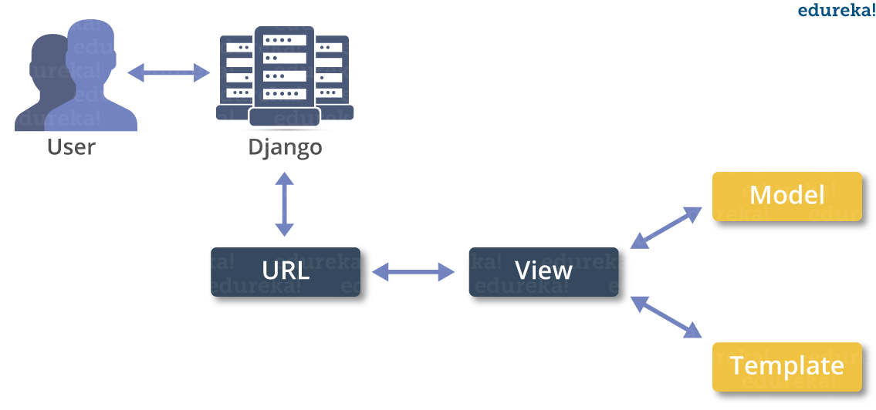

**MACHINE LEARNING**

* What is Machine Learning

1. Machine Learning is the science (and art) of programming computers so they can learn from data.
2. Machine Learning is a step into the direction of artificial intelligence (AI).
3. Machine Learning is a program that analyses data and learns to predict the outcome.
4. Machine learning is a growing technology which enables computers to learn automatically from past data.
5. Machine learning uses various algorithms for building mathematical models and making predictions using historical data or information. Currently, it is being used for various tasks such as image recognition, speech recognition, email filtering etc..

**How does Machine Learning work**

* A Machine Learning system learns from historical data, builds the prediction models, and whenever it receives new data, predicts the output for it.
* The accuracy of predicted output depends upon the amount of data, as the huge amount of data helps to build a better model which predicts the output more accurately.

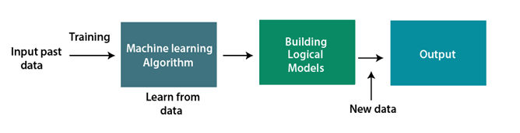

**Features of Machine Learning**

* Machine learning uses data to detect various patterns in a given dataset.
* It can learn from past data and improve automatically.
* Machine learning is much similar to data mining as it also deals with the huge amount of the data.

**What is Train/Test**

Train/Test is a method to measure the accuracy of your model.

It is called Train/Test because you split the the data set into two sets: a training set and a testing set.

* 80% for training, and 20% for testing.
* You *train* the model using the training set.
* You *test* the model using the testing set.
* *Train* the model means *create* the model.
* *Test* the model means test the accuracy of the model.

**Classification of Machine Learning**

At a broad level, machine learning can be classified into three types:

* **Supervised learning**
* **Unsupervised learning**
* **Reinforcement learning**

**INPUT AND OUTPUT DESIGN**

**INPUT DESIGN**

The input design is the link between the information system and the user. It comprises the developing specification and procedures for data preparation and those steps are necessary to put transaction data in to a usable form for processing can be achieved by inspecting the computer to read data from a written or printed document or it can occur by having people keying the data directly into the system. The design of input focuses on controlling the amount of input required, controlling the errors, avoiding delay, avoiding extra steps and keeping the process simple. The input is designed in such a way so that it provides security and ease of use with retaining the privacy. Input Design considered the following things:

* What data should be given as input?
* How the data should be arranged or coded?
* The dialog to guide the operating personnel in providing input.
* Methods for preparing input validations and steps to follow when error occur.

**OBJECTIVES**

1.Input Design is the process of converting a user-oriented description of the input into a computer-based system. This design is important to avoid errors in the data input process and show the correct direction to the management for getting correct information from the computerized system.

2.It is achieved by creating user-friendly screens for the data entry to handle large volume of data. The goal of designing input is to make data entry easier and to be free from errors. The data entry screen is designed in such a way that all the data manipulates can be performed. It also provides record viewing facilities.

3.When the data is entered it will check for its validity. Data can be entered with the help of screens. Appropriate messages are provided as when needed so that the user will not be in maize of instant. Thus the objective of input design is to create an input layout that is easy to follow

**OUTPUT DESIGN**

A quality output is one, which meets the requirements of the end user and presents the information clearly. In any system results of processing are communicated to the users and to other system through outputs. In output design it is determined how the information is to be displaced for immediate need and also the hard copy output. It is the most important and direct source information to the user. Efficient and intelligent output design improves the system’s relationship to help user decision-making.

1. Designing computer output should proceed in an organized, well thought out manner; the right output must be developed while ensuring that each output element is designed so that people will find the system can use easily and effectively. When analysis design computer output, they should Identify the specific output that is needed to meet the requirements.

2.Select methods for presenting information.

3.Create document, report, or other formats that contain information produced by the system.

The output form of an information system should accomplish one or more of the following objectives.

* Convey information about past activities, current status or projections of the
* Future.
* Signal important events, opportunities, problems, or warnings.
* Trigger an action.
* Confirm an action.

**SYSTEM STUDY**

**FEASIBILITY STUDY**

The feasibility of the project is analyzed in this phase and business proposal is put forth with a very general plan for the project and some cost estimates. During system analysis the feasibility study of the proposed system is to be carried out. This is to ensure that the proposed system is not a burden to the company. For feasibility analysis, some understanding of the major requirements for the system is essential.

**THREE KEY CONSIDERATIONS INVOLVED IN THE FEASIBILITY ANALYSIS ARE,**

* **ECONOMICAL FEASIBILITY**
* **TECHNICAL FEASIBILITY**
* **SOCIAL FEASIBILITY**

**ECONOMICAL FEASIBILITY**

This study is carried out to check the economic impact that the system will have on the organization. The amount of fund that the company can pour into the research and development of the system is limited. The expenditures must be justified. Thus the developed system as well within the budget and this was achieved because most of the technologies used are freely available. Only the customized products had to be purchased.

### TECHNICAL FEASIBILITY

This study is carried out to check the technical feasibility, that is, the technical requirements of the system. Any system developed must not have a high demand on the available technical resources. This will lead to high demands on the available technical resources. This will lead to high demands being placed on the client. The developed system must have a modest requirement, as only minimal or null changes are required for implementing this system.

**SOCIAL FEASIBILITY**

The aspect of study is to check the level of acceptance of the system by the user. This includes the process of training the user to use the system efficiently. The user must not feel threatened by the system, instead must accept it as a necessity. The level of acceptance by the users solely depends on the methods that are employed to educate the user about the system and to make him familiar with it. His level of confidence must be raised so that he is also able to make some constructive criticism, which is welcomed, as he is the final user of the system.

**SYSTEM TEST**

The purpose of testing is to discover errors. Testing is the process of trying to discover every conceivable fault or weakness in a work product. It provides a way to check the functionality of components, sub assemblies, assemblies and/or a finished product It is the process of exercising software with the intent of ensuring that the Software system meets its requirements and user expectations and does not fail in an unacceptable manner. There are various types of test. Each test type addresses a specific testing requirement.

### TYPES OF TESTS

**Unit testing**

Unit testing involves the design of test cases that validate that the internal program logic is functioning properly, and that program inputs produce valid outputs. All decision branches and internal code flow should be validated. It is the testing of individual software units of the application .it is done after the completion of an individual unit before integration. This is a structural testing, that relies on knowledge of its construction and is invasive. Unit tests perform basic tests at component level and test a specific business process, application, and/or system configuration. Unit tests ensure that each unique path of a business process performs accurately to the documented specifications and contains clearly defined inputs and expected results.

**Integration testing**

Integration tests are designed to test integrated software components to determine if they actually run as one program. Testing is event driven and is more concerned with the basic outcome of screens or fields. Integration tests demonstrate that although the components were individually satisfaction, as shown by successfully unit testing, the combination of components is correct and consistent. Integration testing is specifically aimed at exposing the problems that arise from the combination of components.

**Functional test**

Functional tests provide systematic demonstrations that functions tested are available as specified by the business and technical requirements, system documentation, and user manuals.

Functional testing is centered on the following items:

Valid Input : identified classes of valid input must be accepted.

Invalid Input : identified classes of invalid input must be rejected.

Functions : identified functions must be exercised.

Output : identified classes of application outputs must be exercised.

Systems/Procedures : interfacing systems or procedures must be invoked.

Organization and preparation of functional tests is focused on requirements, key functions, or special test cases. In addition, systematic coverage pertaining to identify Business process flows; data fields, predefined processes, and successive processes must be considered for testing. Before functional testing is complete, additional tests are identified and the effective value of current tests is determined.

**System Test**

System testing ensures that the entire integrated software system meets requirements. It tests a configuration to ensure known and predictable results. An example of system testing is the configuration oriented system integration test. System testing is based on process descriptions and flows, emphasizing pre-driven process links and integration points.

**White Box Testing**

White Box Testing is a testing in which in which the software tester has knowledge of the inner workings, structure and language of the software, or at least its purpose. It is purpose. It is used to test areas that cannot be reached from a black box level.

**Black Box Testing**

Black Box Testing is testing the software without any knowledge of the inner workings, structure or language of the module being tested. Black box tests, as most other kinds of tests, must be written from a definitive source document, such as specification or requirements document, such as specification or requirements document. It is a testing in which the software under test is treated, as a black box .you cannot “see” into it. The test provides inputs and responds to outputs without considering how the software works.

**Unit Testing**

Unit testing is usually conducted as part of a combined code and unit test phase of the software lifecycle, although it is not uncommon for coding and unit testing to be conducted as two distinct phases.

**Test strategy and approach**

Field testing will be performed manually and functional tests will be written in detail.

**Test objectives**

* All field entries must work properly.
* Pages must be activated from the identified link.
* The entry screen, messages and responses must not be delayed.

**Features to be tested**

* Verify that the entries are of the correct format
* No duplicate entries should be allowed
* All links should take the user to the correct page.

# Integration Testing

Software integration testing is the incremental integration testing of two or more integrated software components on a single platform to produce failures caused by interface defects.

The task of the integration test is to check that components or software applications, e.g. components in a software system or – one step up – software applications at the company level – interact without error.

**Test Results:**All the test cases mentioned above passed successfully. No defects encountered.

**Acceptance Testing**

User Acceptance Testing is a critical phase of any project and requires significant participation by the end user. It also ensures that the system meets the functional requirements.

**Test Results:**All the test cases mentioned above passed successfully. No defects encountered.

**App.py**

@app.route('/upload', methods=['POST'])

def upload():

    if 'owner' not in session:

        return redirect('/owner_login')

    try:

        file = request.files['file']

        cover_image = request.files['cover']

        data = file.read()

        owner_email = session['owner']['email']

        # Encrypt

        ciphertext, key, iv = encrypt_aes(data)

        combined_data = iv + ciphertext

        data_len = len(combined_data)

        # Embed in image (steganography)

        cover_image_bytes = BytesIO(cover_image.read())

        stego_bytes = embed_data_in_image(cover_image_bytes, combined_data)

        # Save to DB

        conn = mysql.connector.connect(**DB_CONFIG)

        cursor = conn.cursor()

        cursor.execute(

            "INSERT INTO files (filename, stego_image, aes_key, data_len, owner_email) VALUES (%s, %s, %s, %s, %s)",

            (file.filename, stego_bytes, key, data_len, owner_email)

        )

        conn.commit()

        cursor.close()

        conn.close()

        # Convert ciphertext and key to hex to display

        cipher_hex = ciphertext.hex()

        key_hex = key.hex()

        iv_hex = iv.hex()

        # Prepare stego image preview as base64

        import base64

        stego_base64 = base64.b64encode(stego_bytes).decode('utf-8')

        flash("✅ File uploaded successfully!", "success")

        return render_template(

            'owner.html',

            owner=session['owner'],

            show_process=True,

            original_filename=file.filename,

            key_hex=key_hex,

            iv_hex=iv_hex,

            cipher_hex=cipher_hex,

            stego_base64=stego_base64

        )

    except ValueError as e:

        flash(f"⚠️ {str(e)}", "danger")

        return redirect('/owner_dashboard')

**SCREENSHOTS**

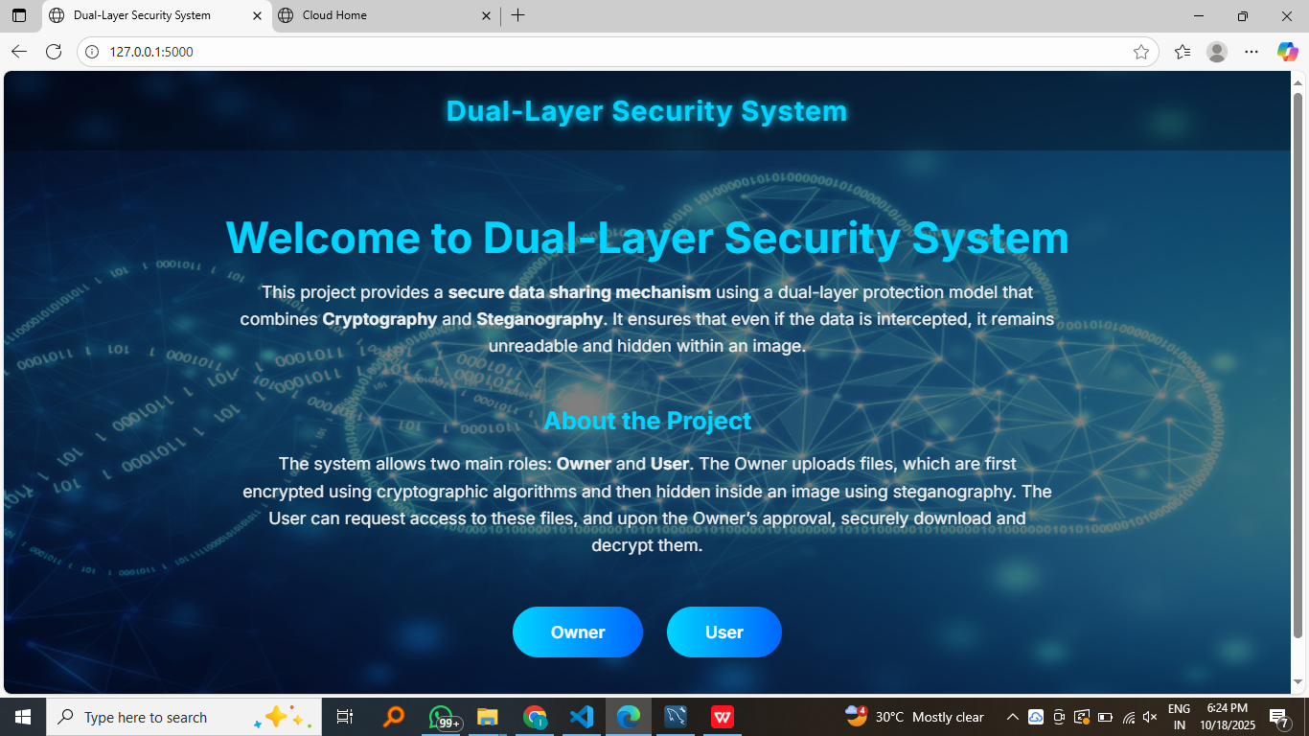

Index

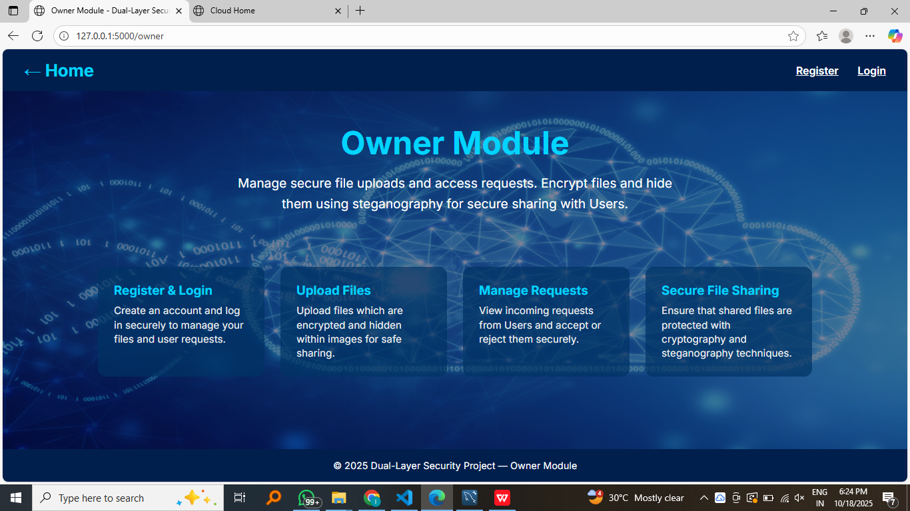

Owner index

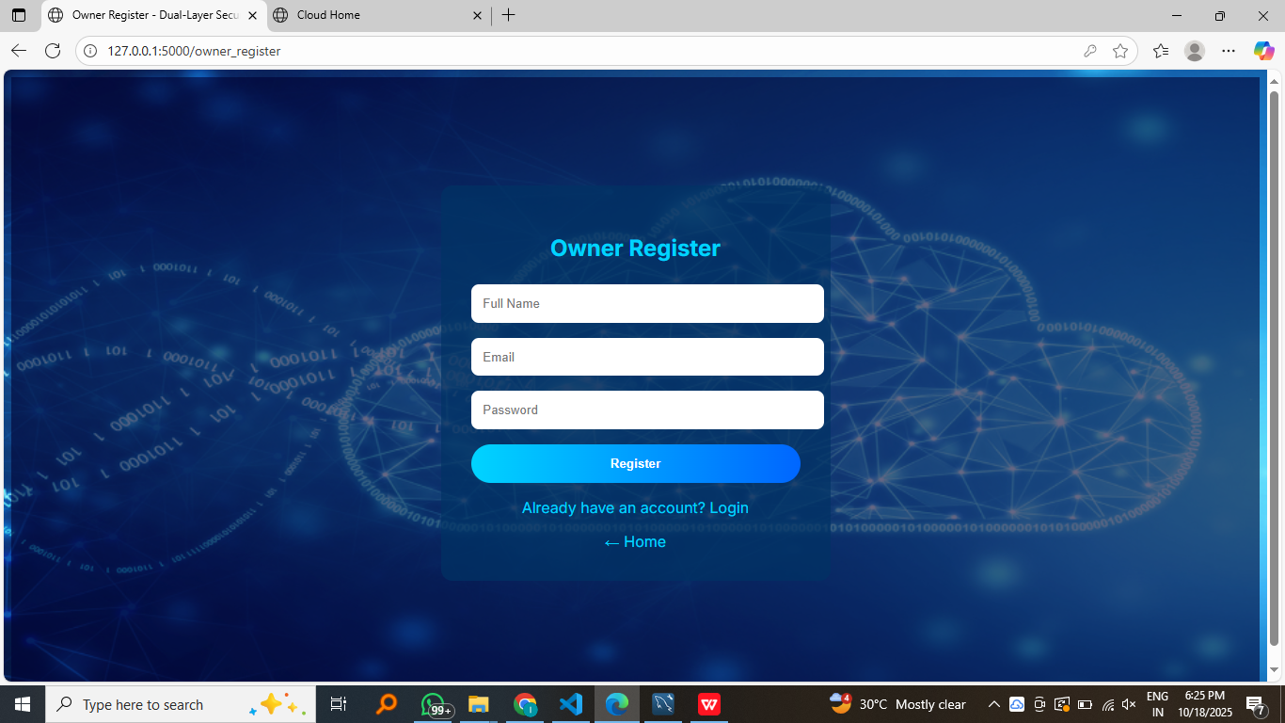

Owner registration

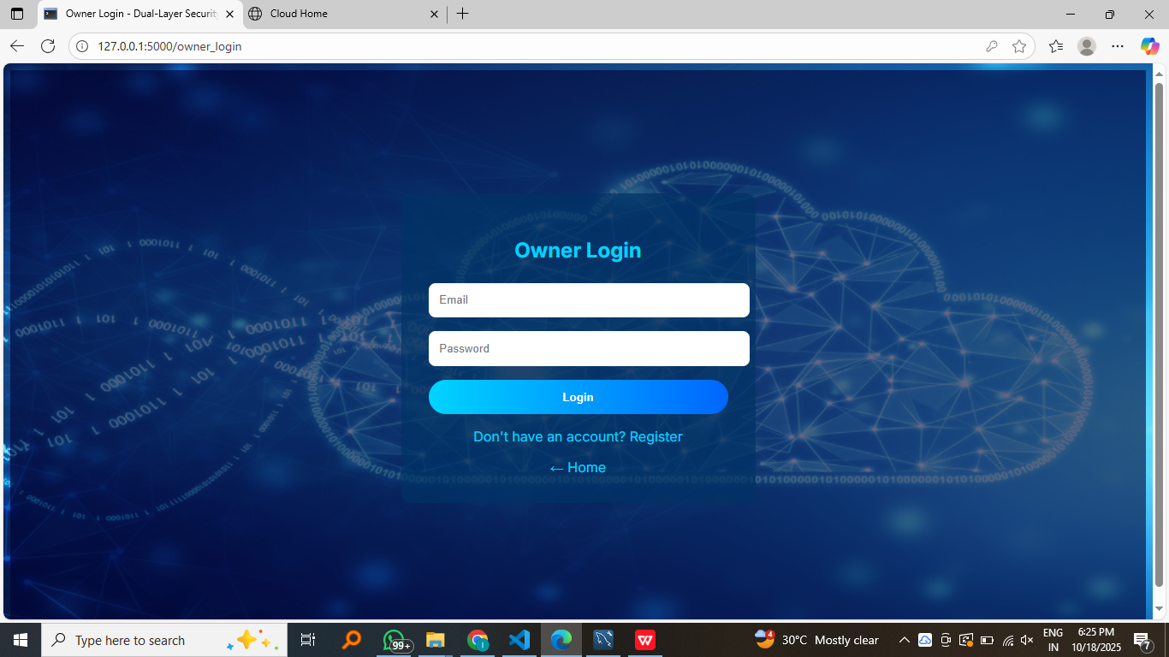

Owner login

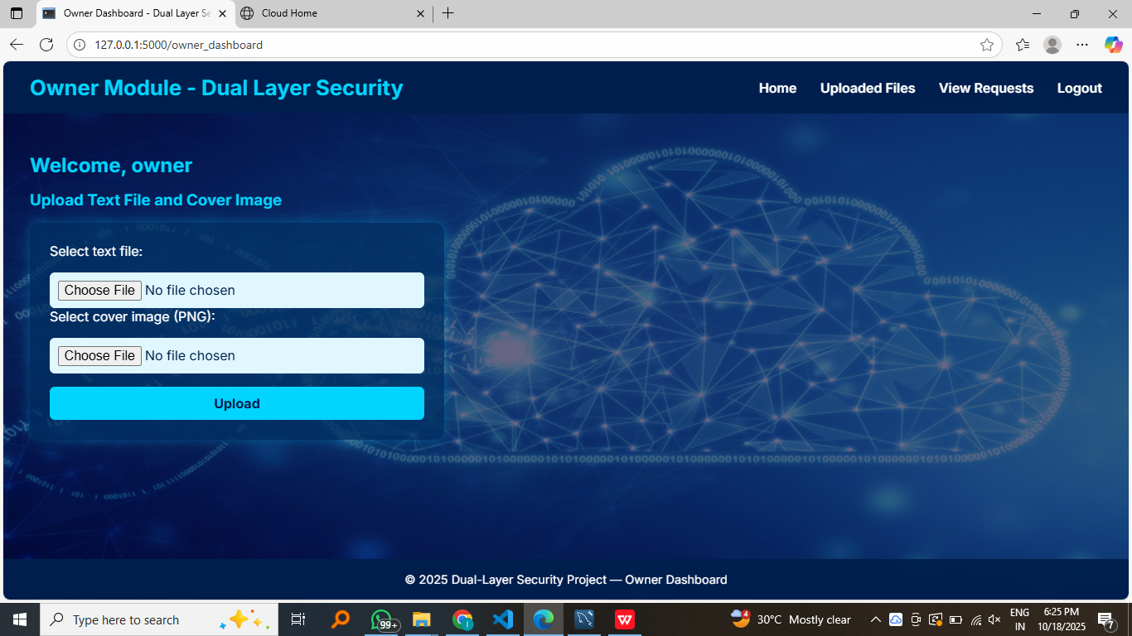

Owner dashboard

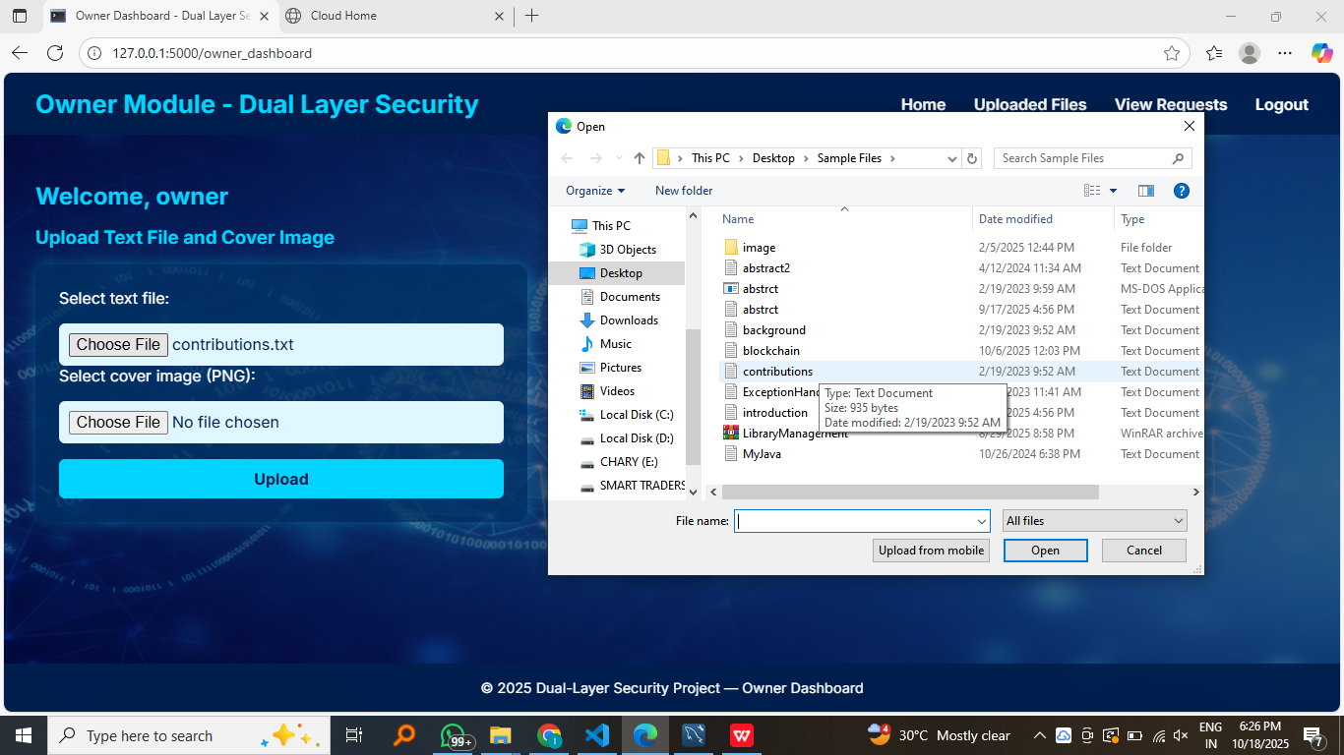

Owner upload text file

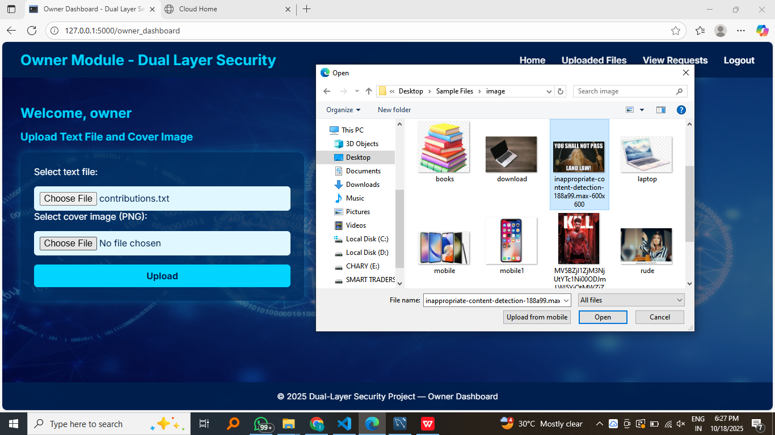

Owner upload an image for steganography

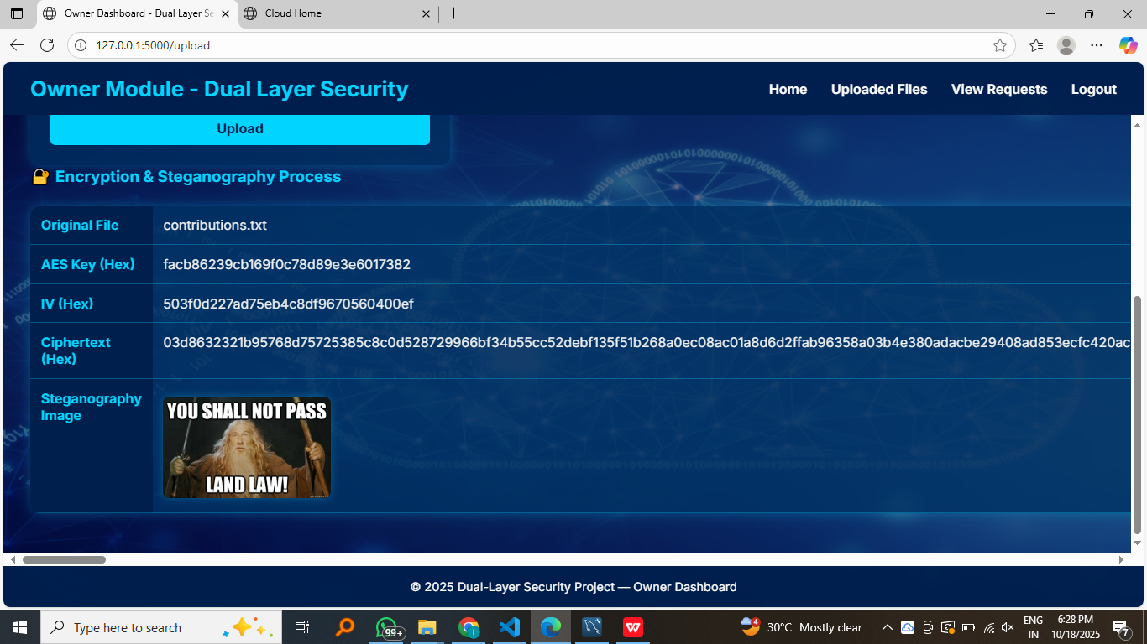

File is encrypted and steganographed

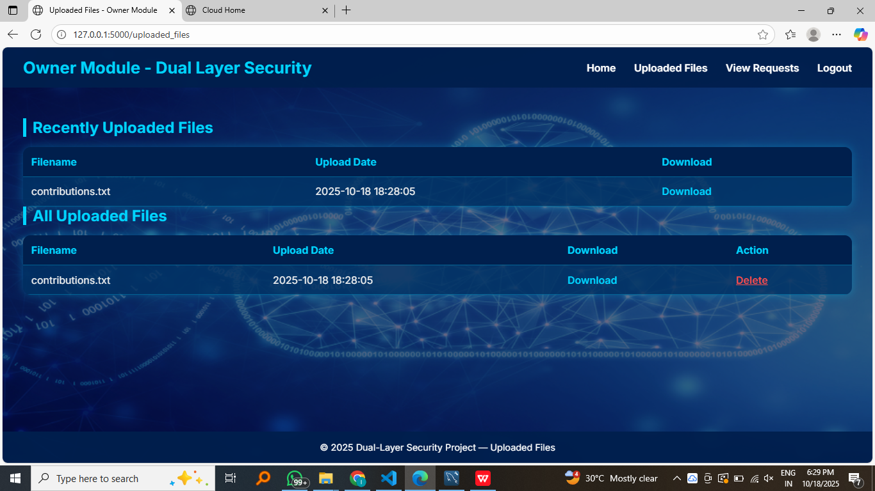

Owner can see all his uploaded files and he can also download it

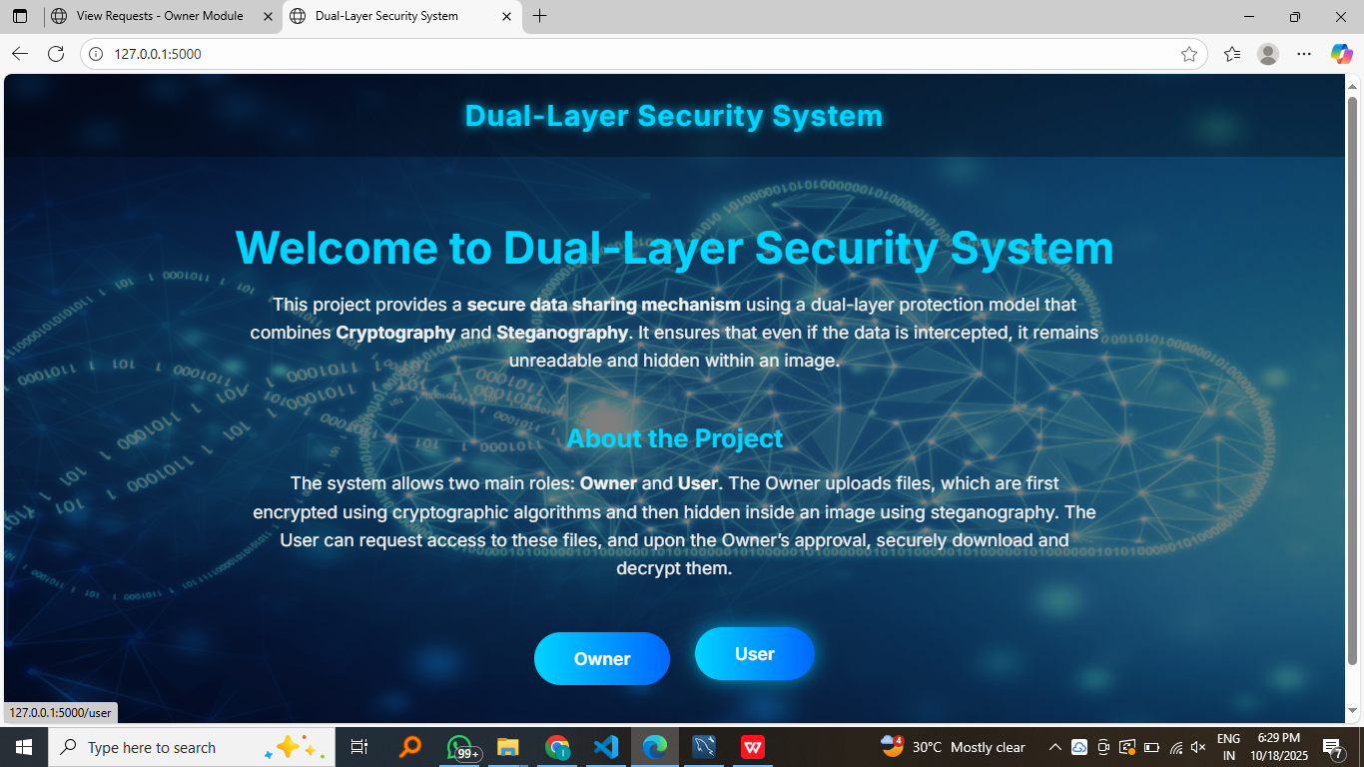

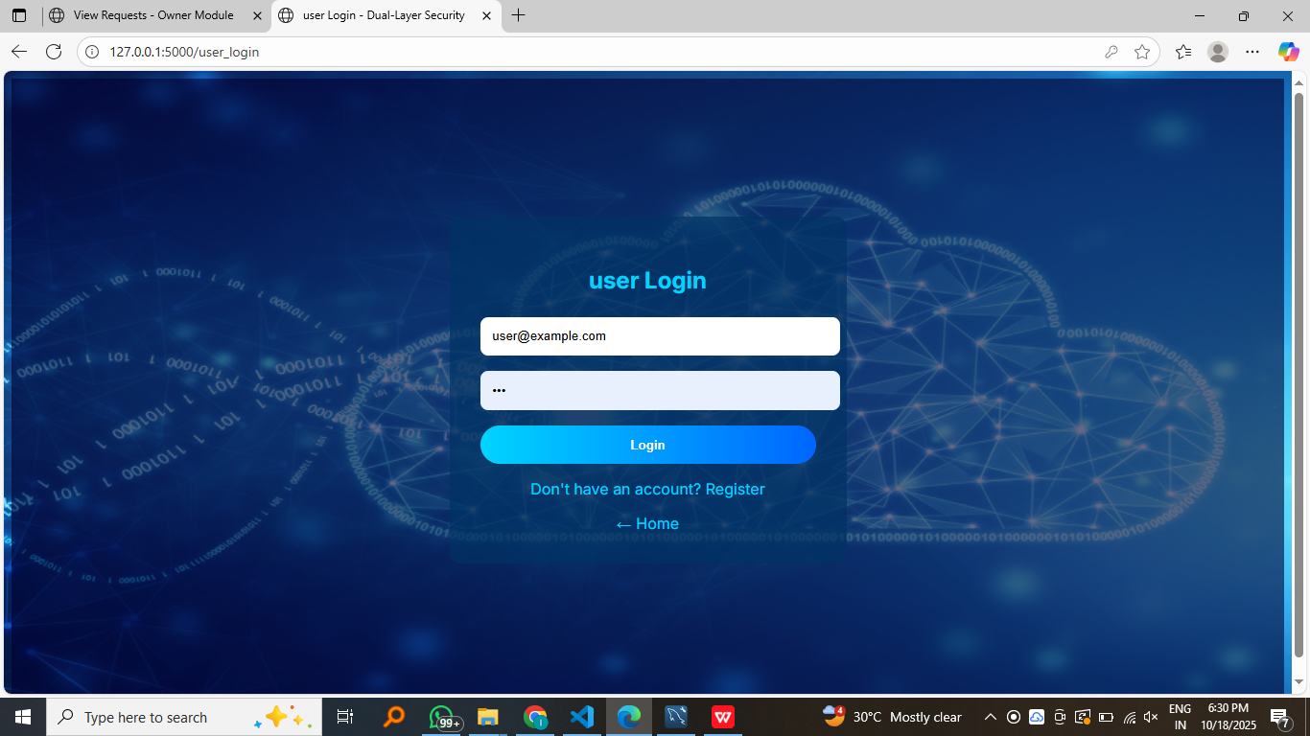

User login

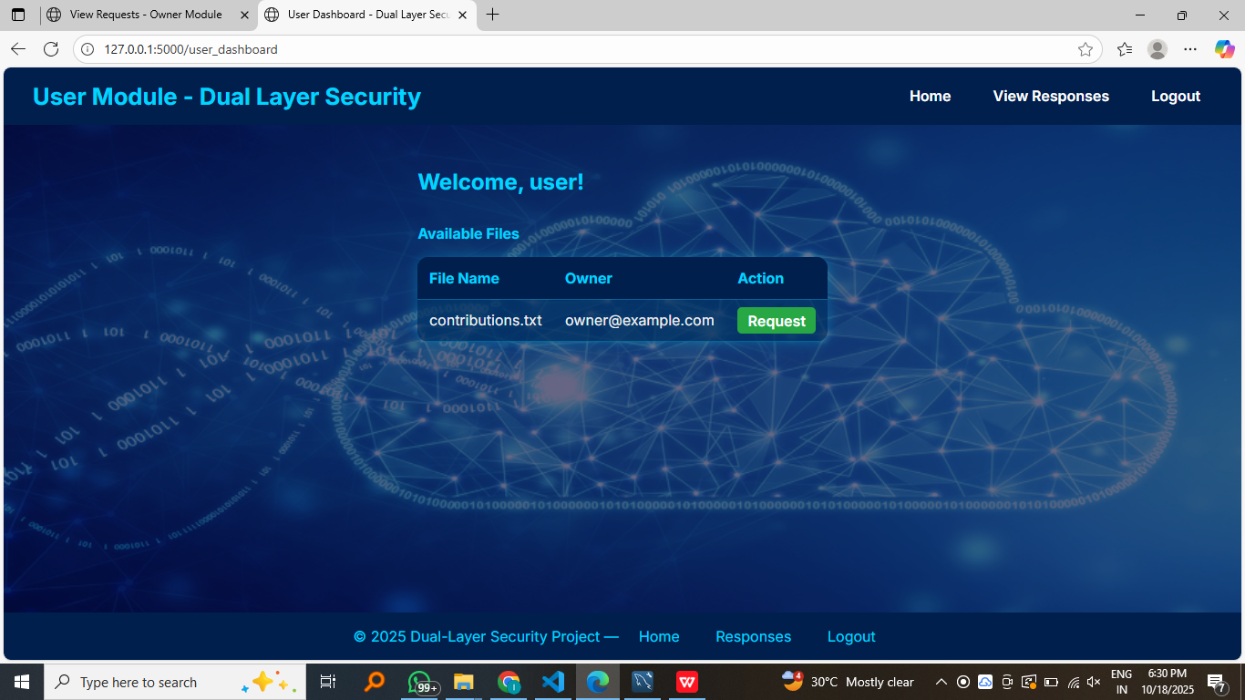

User can view all the uploaded files and request

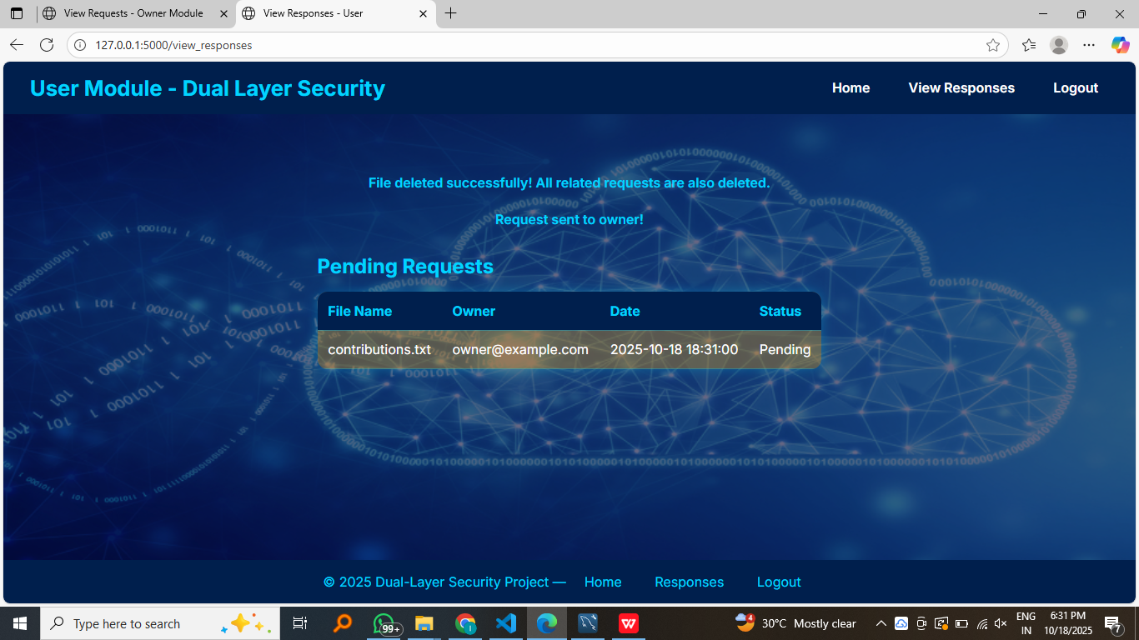

Requested file are intially pending as the owner is not accepted the request

Owner > viewrequests :

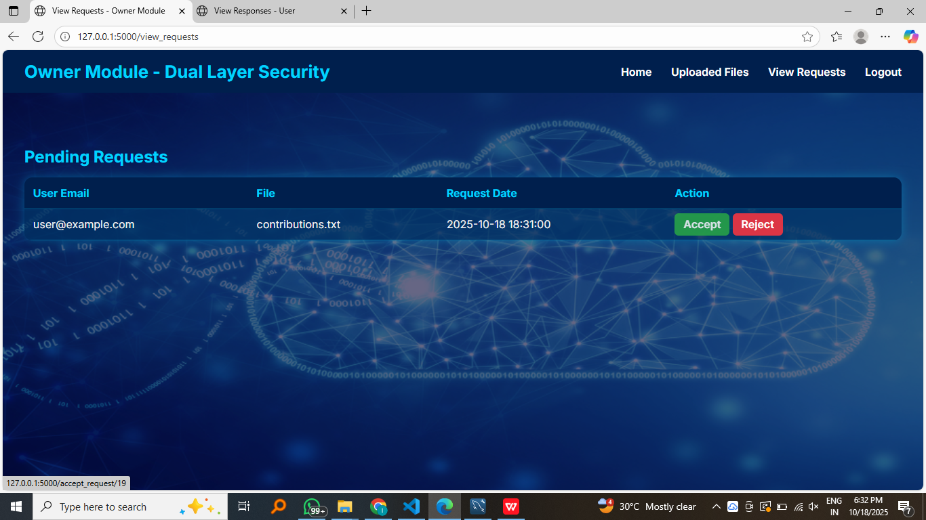

Owner accepts the request

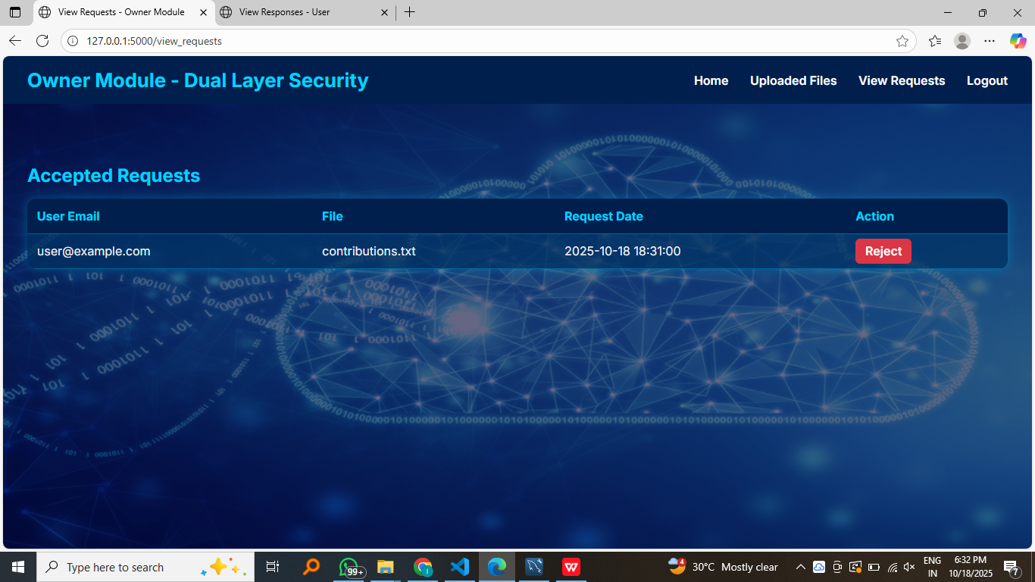

Owner can see all his accepted requests of users in accepted requests table

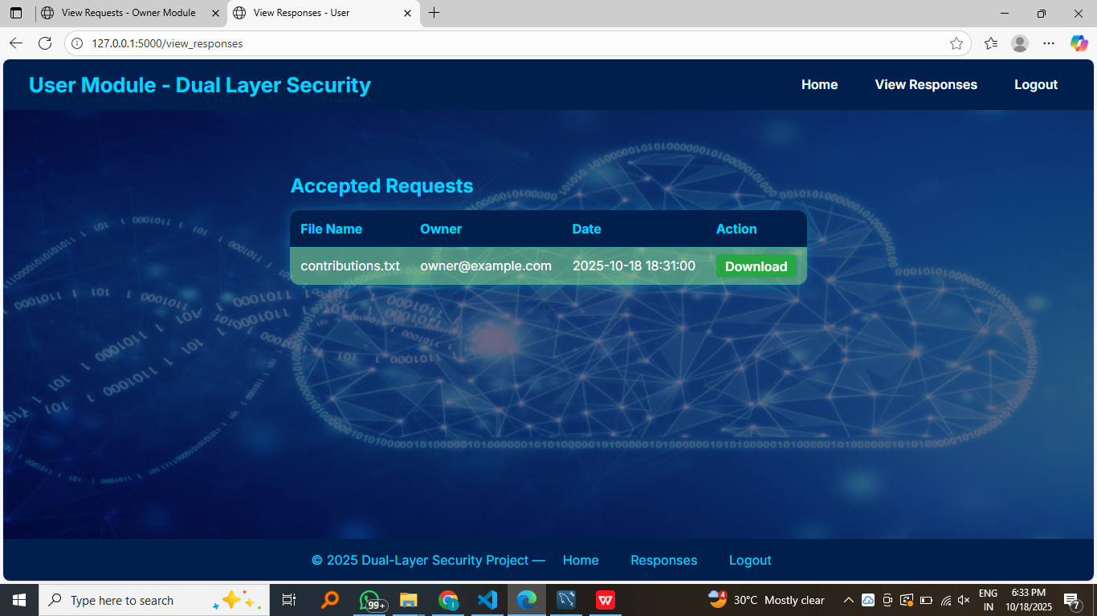

User can see the response . if the owner accpted the request of user he can now download

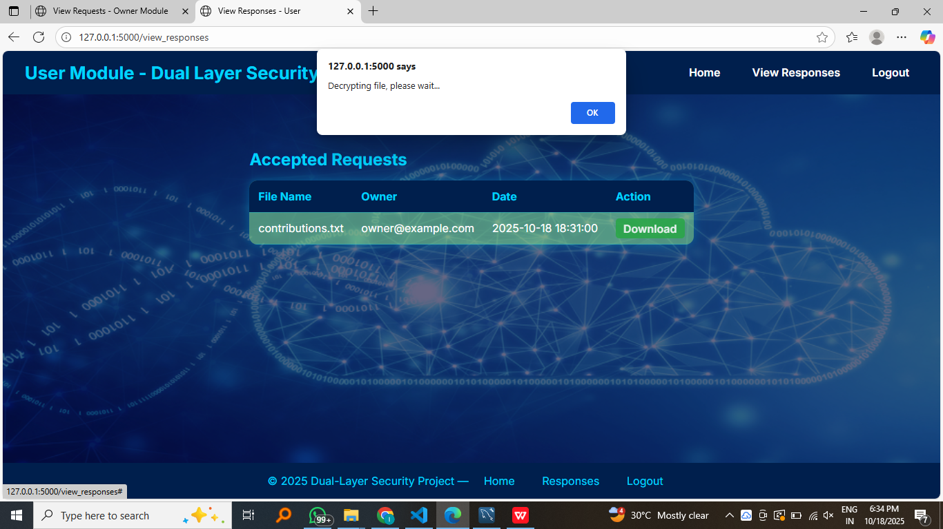

File is getting automatically decrypted and downloaded

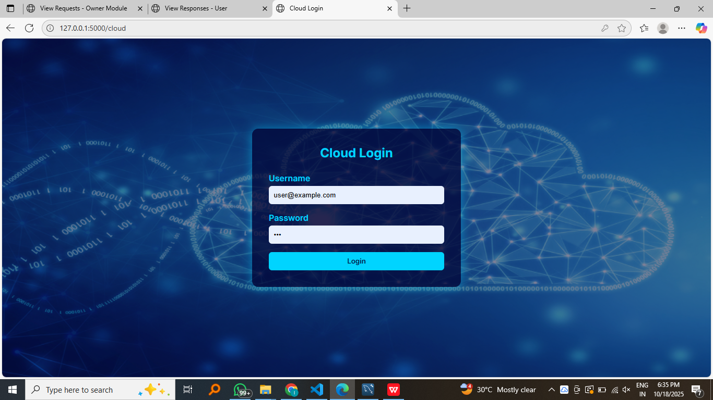

Access the cloud module using Url : http://127.0.0.1:5000/cloud

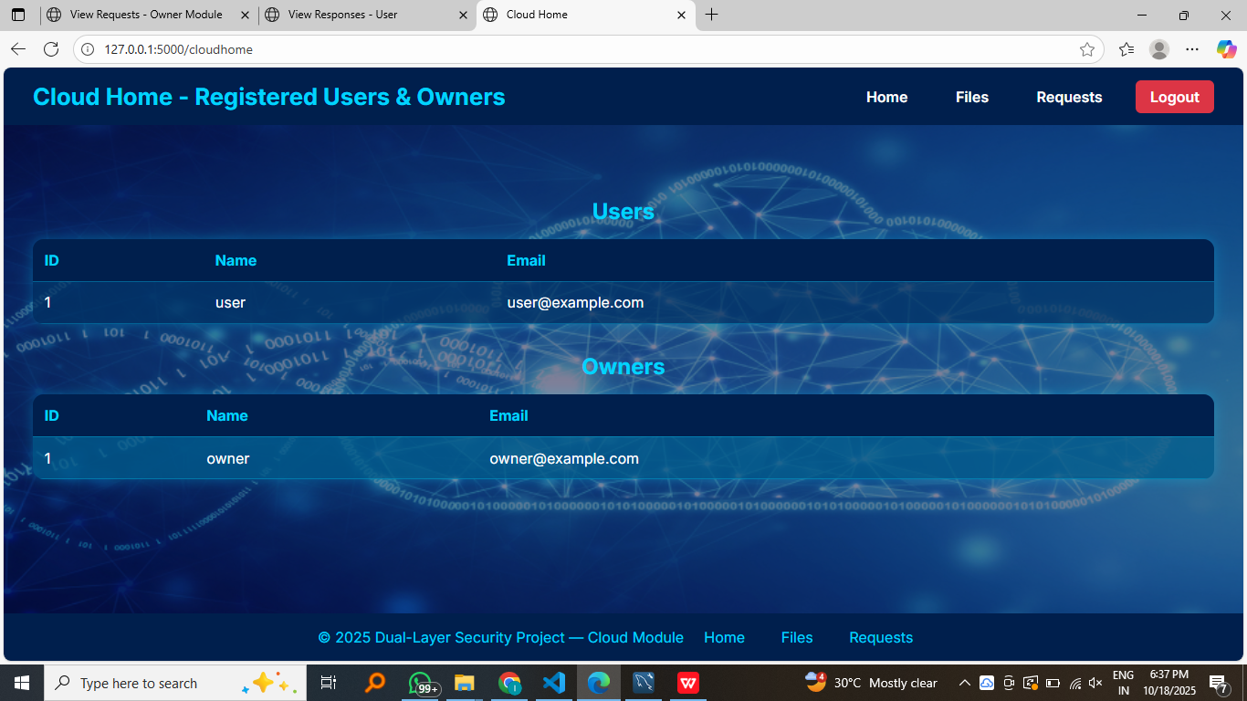

Access registed users and owners

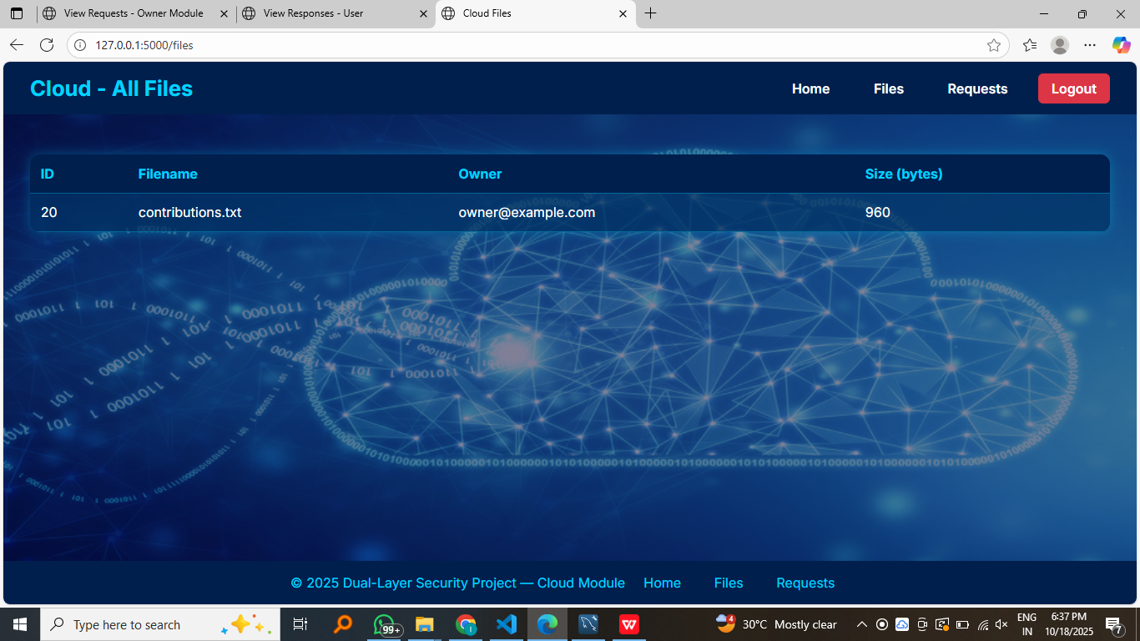

Access all files

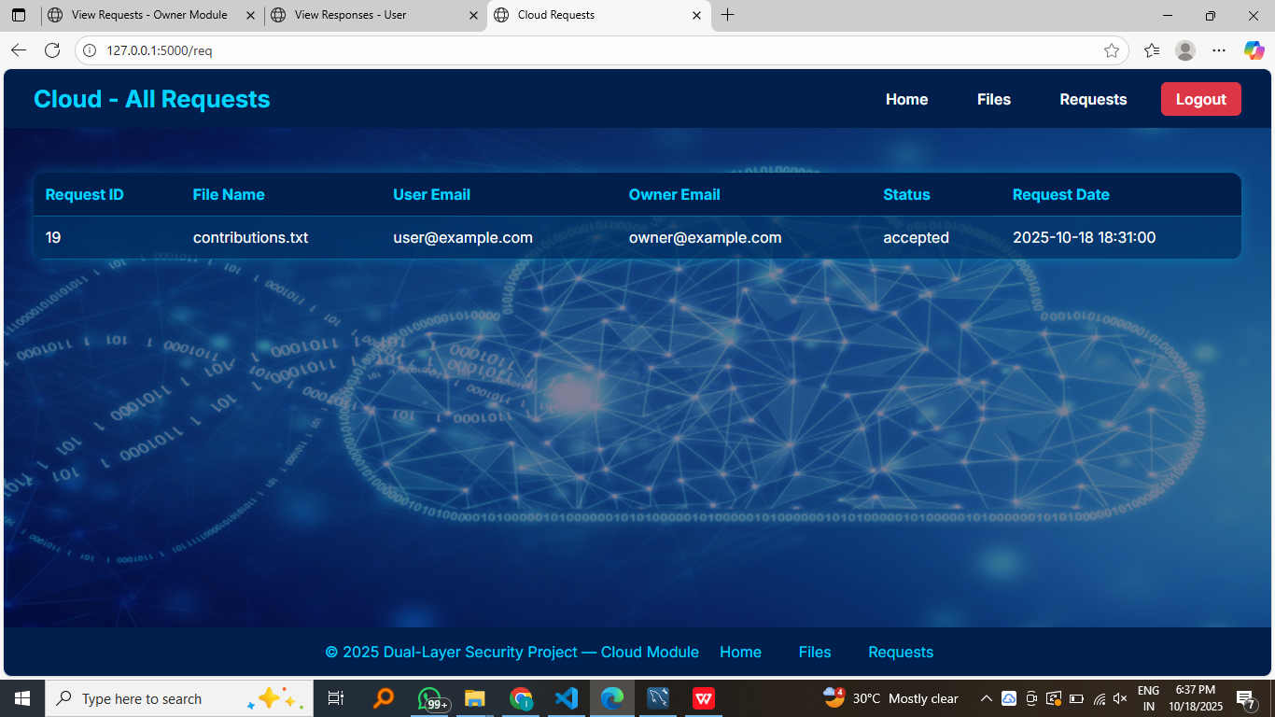

Access all requests

**CONCLUSION**

This project delivers a comprehensive data security solution by combining cryptography and steganography into a dual-layer model, along with a multi‐module system for access control and monitoring. The combination of encryption and hiding ensures that even if an attacker obtains the stored image they cannot see or easily identify the secret data. Controlled access through owner approval and centralized monitoring via the cloud module ensures accountability. The system demonstrates practical viability and enhances traditional data protection methods.

**FUTURE SCOPE**

Future enhancements could include using more advanced steganographic carriers (audio, video), adaptive embedding strategies to increase capacity and imperceptibility, integration of blockchain for immutable audit logs of file uploads/requests, support for heterogeneous file types (images, videos, documents), and incorporating machine-learning steganalysis detection and resistance mechanisms to further harden the system.

**REFERENCES**

· · A. Jan, “Double layer security using crypto-stego techniques,” International Journal of Advanced Research in Computer and Communication Engineering, vol. 10, no. 1, pp. 48-52, 2021.

· B. Kallapu, A. N. Janardhan, R. M. Hejamadi, K. R. N. Shrinivas, Saritha, R. K. Ramesh and L. A. Gabralla, “Multi-Layered Security Framework Combining Steganography and DNA Coding,” Systems, vol. 13, no. 5, Article 341, 2025

· M. M. Abd Zaid, A. Ali Talib Al-khazaali and A. Abed Mohammed, “LSB Steganography using Dual Layer for Text Crypto-Stego,” BIO Web of Conferences, 2024.

· A. O. Aljahdali, “Double layer steganography technique using DNA sequences and images as carriers for sensitive data,” PMC article, 2023.

· A. Sykot, M. S. Azad, W. R. Tanha, B. M. Morshed and S. E. Uddin Shubha, “Multi-Layered Security System: Integrating Quantum Key Distribution with Classical Cryptography to Enhance Steganographic Security,” arXiv preprint, 2024.

· S. Singh and V. K. Attri, “Dual Layer Security of data using LSB Image Steganography Metod and AES Encryption Algorithm,” International Journal of Signal Processing, Image Processing and Pattern Recognition, vol. 8, no. 5, pp. 259-266, 2015

· Y. Sanjalawe, S. Al-E’mari, S. Fraihat, M. Abualhaj and E. Alzubi, “A deep learning-driven multi-layered steganographic approach for enhanced data security,” Scientific Reports, vol. 15, Article 4761, 2025.